Module 06 Activity – Performing Calculations

Tracy Brevig

Rasmussen College

COURSE#: W110/COP1801 Section 01 Javascript

Instructor’s Name: Kimberly Powell

March 18, 2021

**Screenshots of the loaded page:**

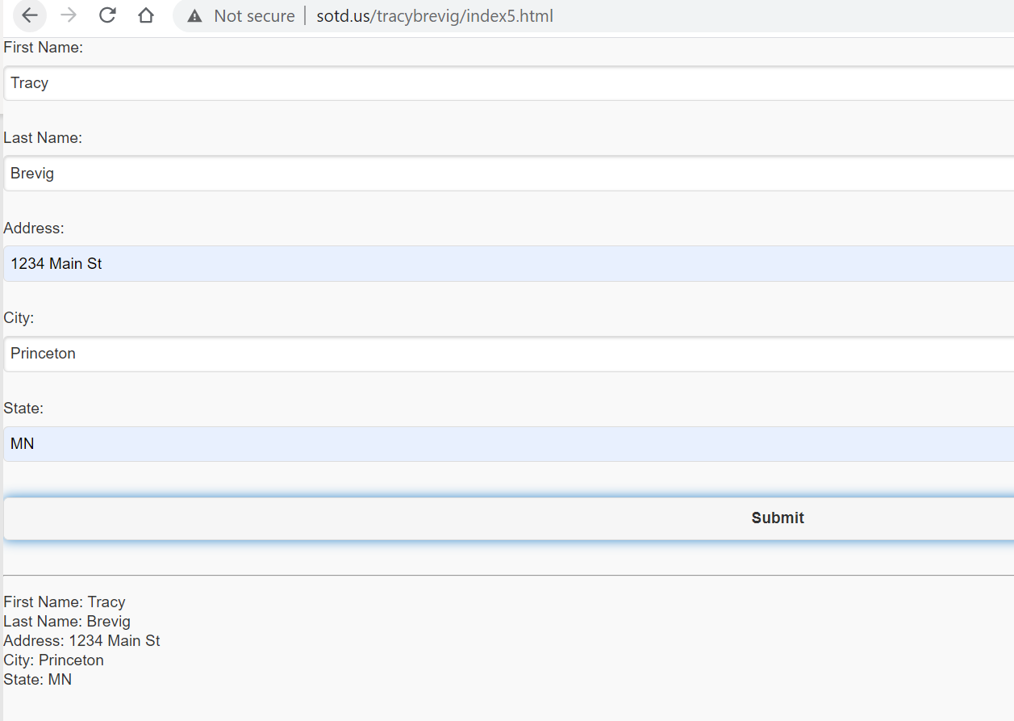

URL Link

<http://sotd.us/tracybrevig/index5.html>

Git Hub URL

<https://github.com/tbrevig/COP1801_Javascript/commit/4cad59ab7754f93e4fa4e3b0317c76da590baaf7>